HTML Quotation

**Table of content**

* What do you mean by HTML Quotation?
* Explain HTML quotation and citation elements with example?
* What is inline Quotation element?

**What do you mean by HTML Quotation?**

HTML Quotation is use for inserting some quotation text into your webpage. Quotation text is different that your normal text because text consists of quoted element which makes the text different than your normal text in your webpage.

**Example-**

<!DOCTYPE html>

<html>

  <head>

    <title>Quotation tag</title>

  </head>

  <body>

    <h2>Geeky4u.com (Learn with Passion)</h2>

    <p>

      Geeky4u.com (Learn with Passion):

      <q

        >This is a best platform where we are providing best study material,

        best content so that it is easy for you to learn everything and no one

        will stop you to become a master in programming language</q>

    </p>

  </body>

</html>

**Output-**

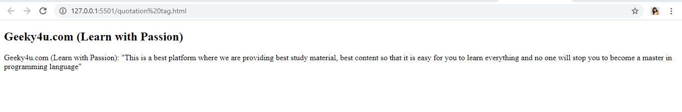

**Explain HTML quotation and citation elements with example?**

**<Blockquote> Quotation in HTML-**

Blockquote tag will allow define or copy a section which is quoted from another link or URL.

**Syntax-**

<html start tag> <blockquote cite=“link”>text < /blockquote></html end tag>

**Example-**

<!DOCTYPE html>

<html>

  <head>

    <title>blockquote tag</title>

  </head>

  <body>

    <h4>In cite attribute you can add any URL which you have quoted in your document </h4>

    <p>

     <blockquote cite="XYZ.com">"Start your day with a smile because you are lucky to have seen a new day"</blockquote>

    </p>

  </body>

</html>

**Output-**

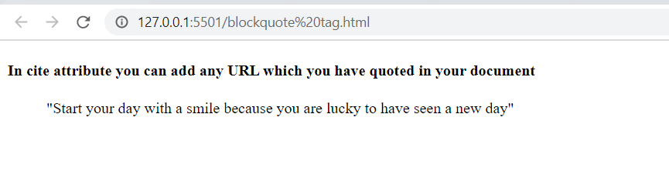

**Explain <q> Quotation tag in HTML-**

< q > tag is use for giving quotation symbol to your text. For quotation symbol we need to use <q > tag in the paragraph tag or heading tag then browser will automatically give the quotation symbol to the text.

**Syntax-**

<html start tag> text <q>text in quotation format. < /q></html end tag>

**Example-**

<!DOCTYPE html>

<html>

  <head>

    <title>Quotation tag</title>

  </head>

  <body>

    <h2>Geeky4u.com (Learn with Passion)</h2>

    <p>

      Geeky4u.com (Learn with Passion):

      <q

        >This is a best platform where we are providing best study material,

        best content so that it is easy for you to learn everything and no one

        will stop you to become a master in programming language</q

      >

    </p>

  </body>

</html>

**Output-**



**Explain abbreviation <abbr> tag in HTML-**

Abbreviation tag is useful for defining the abbreviations such as HTML, CSS, ASAP, ATM etc. It will help the browser to give the important information so that browser can understand the abbreviation with the help of translation system or search engine.

**Syntax-**

<html start tag> text <abbr>text< /abbr></html end tag>

**Example-**

<!DOCTYPE html>

<html>

  <head>

    <title>abbr tag</title>

  </head>

  <body>

    <p>

      The <abbr title="Hyper text mark language">HTML</abbr>is a markup language

    </p>

    <p></p>

  </body>

</html>

**Output-**

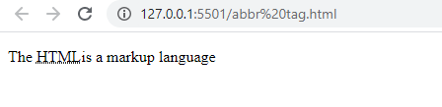

**The address tag <address> in HTML-**

The address tag is use for defining the contact information of a particular person. whatever you write in in the address tag browser will recognize it and convert the text into italic format so that your text will looks like address.

**Syntax-**

<html start tag> <address>Your address< /address></html end tag>

**Example-**

<!DOCTYPE html>

<html>

  <head>

    <title>address tag</title>

  </head>

  <body>

    <h1>GEEKY4U.com</h1>

    <address>

      Article is written by: XYZ.<br />

      Visit us at: GEEKY4U.com <br />

      India.

    </address>

  </body>

</html>

**Output-**

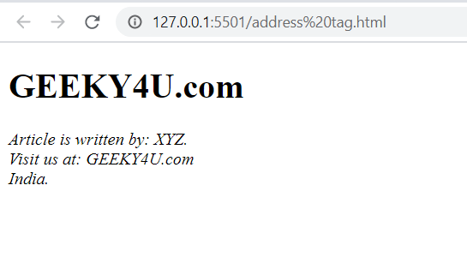

**<cite> tag in HTML-**

The cite tag is use for defining title of your work. Similar to the address tag the content written in the cite tag will be display in the italic format on your browser.

**Note-**

Your name will not consider as the title of your document means you cannot write your name in the title.

**Syntax-**

<html start tag> <cite>content under cite < /cite> title description</html end tag>

**Example-**

<!DOCTYPE html>

<html>

  <head>

    <title>cite tag</title>

  </head>

  <body>

    <h1>GEEKY4U.com</h1>

    <p><cite> Started by </cite> XYZ in 2020.</p>

  </body>

</html>

**Output-**

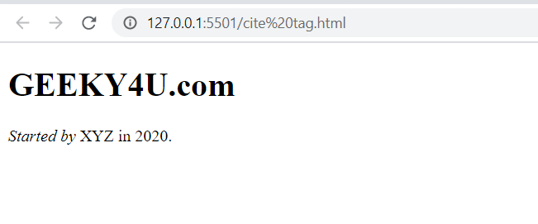

**<bdo> tag in HTML Quotation-**

Bdo means Bi-directional override. Bi-directional override means you can write from right to left or from left to right bdo will allow you to write such content. The use of bdo depends upon the browser only if browser will allow then you can write your text from anywhere from right to left or from left to right.

**Example-**

<!DOCTYPE html>

<html>

  <head>

    <title>bdo tag</title>

  </head>

  <body>

    <h1>GEEKY4U.com</h1>

    <p>

      In below text, GEEKY4U.com is written in thr right to left format by using

      bdo tag.

    </p>

    <bdo dir="rtl">GEEKY4U.com (Learn with Passion)</bdo>

    <p>

      In below text, GEEKY4U.com is written in thr left to right format by using

      bdo tag.

    </p>

    <bdo dir="ltr">GEEKY4U.com (Learn with Passion)</bdo>

  </body>

</html>

**Output-**

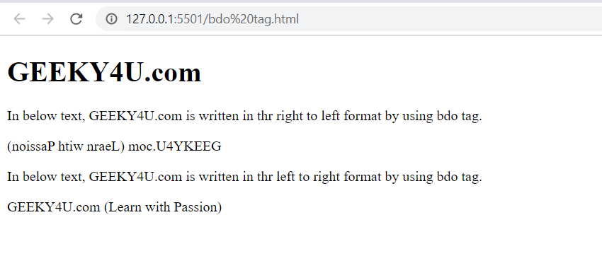

**What is inline Quotation element?**

Quotation is represented by <q> tag. Any text which is written in start <q> and end</q> tag then browser will recognize that the text is in the quotation. Inline quotation is generally use for small quotation. Many browsers use this for wrapping the text into quotation.

**Example-**

<!DOCTYPE html>

<html lang="en">

<head>

    <meta charset="UTF-8">

    <meta name="viewport" content="width=device-width, initial-scale=1.0">

    <title>Document</title>

</head>

<body>

    <h3></h3>

    <p>

     Example of Inline quotation<q>rama requested to rahul, will you please close the door?</q>

    </p>

</body>

</html>

**Output-**

